* **Activity 5:**

Nesting Functions

1. **Display the date of the next Friday that is six months from the hire date:**

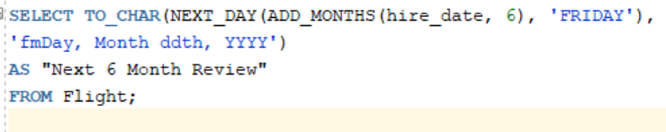

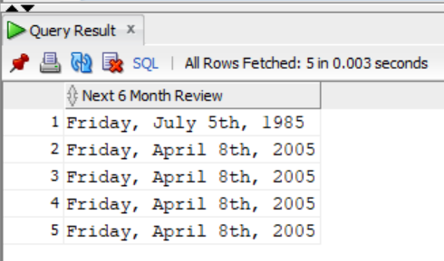Output:

1. **Display ticket prices divided by 7 and rounded:**

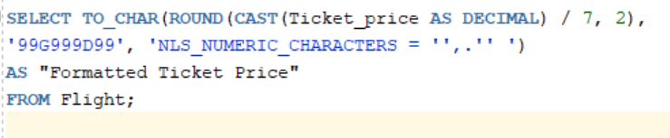

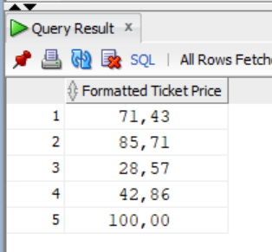Output: